

MBS-712 | Metal Working Bandsaw

50000430T
400/50/3

PARTS LIST
ERSATZTEILLISTE
LISTE DE PIECES


JPW (Tool) AG
Bahnstrasse 24
8603 Schwerzenbach
Switzerland
Phone +41 44 806 47 48
Fax +41 44 806 47 58
www.jettools.com

P-50000430T 02/2014

Breakdown for the MBS-712
Head Assembly

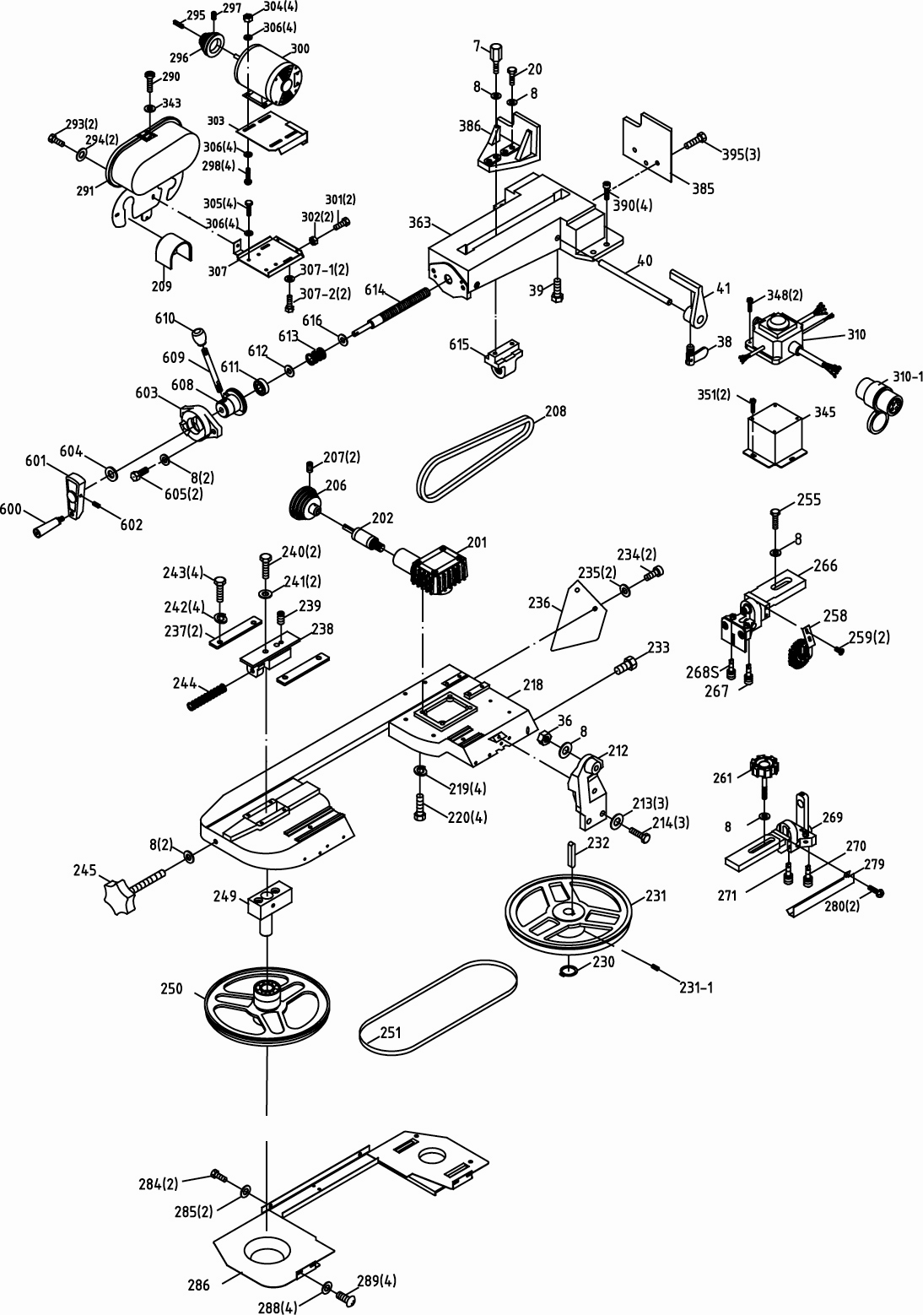

Breakdown for the MBS-712
Gear Box Assembly

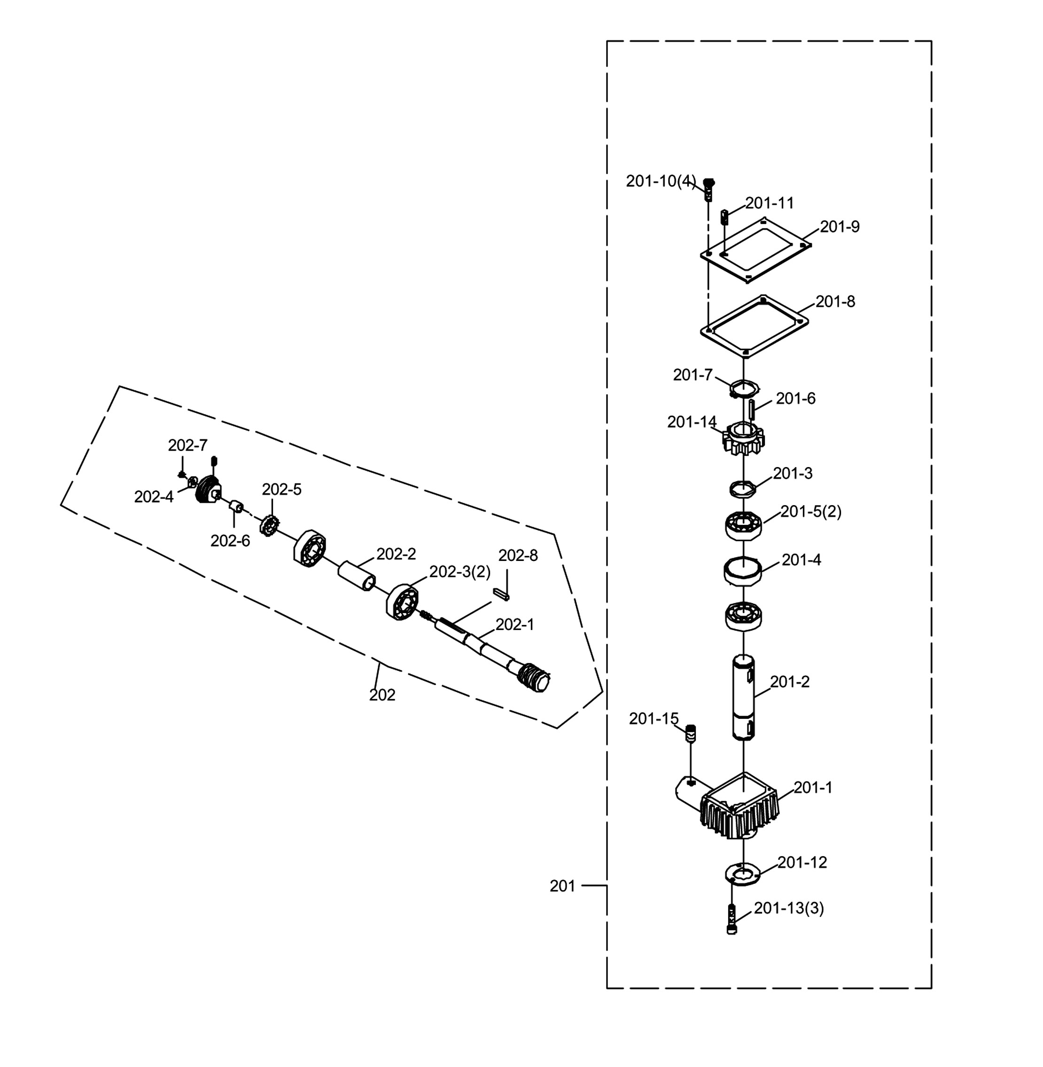

Breakdown for the MBS-712
Bearing Bracket Assembly

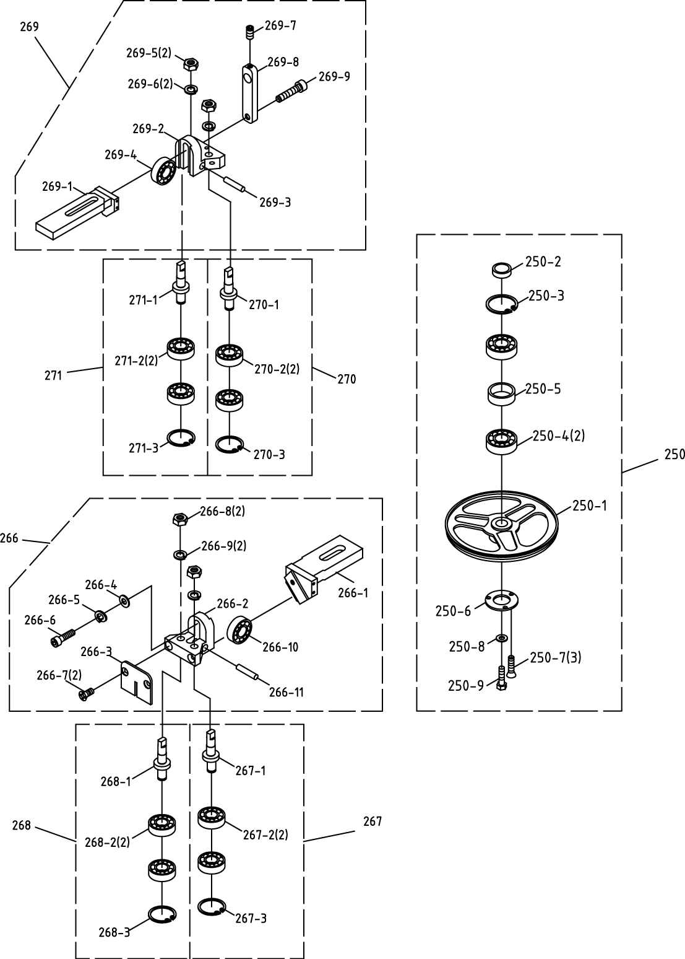

Parts List for the MBS-712
Head Assembly

Index Part
No. No. Description Size Qty.

7 MBS712-007 Fixed Bolt 1
8 TS-0680041 Flat Washer 3/8" 9
20 TS-0060071 Hex Cap Screw 3/8" x 1-1/2" 1
36 TS-0570031 Hex Nut 3/8" 1
38 MBS712-038 Thumb Screw 1
39 TS-0051051 Hex Cap Screw 5/16" x 1" 1
40 MBS712-040 Stock Stop Rod 1
41 MBS712-041 Stock Block 1
201 MBS712-201GBCA……….Gear Box Complete Assembly (included #201A thru #202A and #206, #207)..………1
201A MBS712-201A Gear Box Assembly (#201-1~201-15) 1
201-1 MBS712-201-1 Gear Box 1
201-2 MBS712-201-2 Transmission Wheel Shaft 1
201-3 MBS712-210-3 Bushing 1
201-4 MBS712-201-4 Bushing 1
201-5 MBS712-201-5 Bearing 6205LLU 2
201-6 MBS712-201-6 Key ………………………………………………6 x 6 x 20……………. 1
201-7 MBS712-201-7 C-Retainer Ring S25 1
201-8 MBS712-201-8 Gear Box Gasket 1
201-9 MBS712-201-9 Gear Box Cover 1
201-10 MBS712-201-10 Cross Socket Hex Cap Screw 1/4" x 5/8" 4
201-11 MBS712-201-11 Vent Plug M8 x P1 1
201-12 MBS712-201-12 Bearing Cover 1
201-13 MBS712-201-13 Cross Round Head Screw 3/16" x 3/8" 3
201-14 MBS712-201-14 Worm Gear (Copper) 1
MBS712-201-14S Worm Gear (Steel) 1
201-15 TS-0270051 Socket Set Screw 5/16" x 1/2" 1
202A MBS712-202A Worm Gear Shaft Assembly (#202-1~202-8)…. 1
202-1 MBS712-202-1 Worm Shaft 1
202-2 MBS712-202-2 Bearing Bushing 1
202-3 MBS712-202-3 Bearing 6003LLU 2
202-4 TS-0680061 Flat Washer……… 1/2” 1
202-5 MBS712-202-5 Hex Nut.............................................................M42xP2................ 1
202-6 MBS712-202-6 Bushing 1
202-7 MBS712-202-7 Lock Nut...........................................................1/2"-12.................. 1
202-8 MBS712-202-8 Key …………….………………………………...5x5x30…. 1
206 MBS712-206 Spindle Pulley 1
207 TS-0267042 Socket Set Screw 1/4" x 3/8" 2
208 MBS712-208 V-Belt………..…………………………….............3V x 270. 1
209 MBS712-209 Cover.………..…………………………….............. 1
212 MBS712-212 Cylinder Upper Support 1
213 TS-0680031 Flat Washer 5/16" 3
214 TS-0081031 Hex Cap Screw 5/16" x 3/4” 3
218 MBS712-218 Body Frame 1
219 TS-0720091 Spring Washer 3/8" 4
220 TS-0060061 Hex Cap Screw 3/8" x 1-1/4" 4
230 MBS712-230 C-Retainer Ring S25 1
231 MBS712-231 Drive Wheel FC25 1
231-1 TS-0267041 Socket Set Screw 1/4” x 3/8” 2
232 MBS712-232 Key ……………………….……………………...6x6x20……………. 1
233 TS-0051051 Hex Cap Screw 5/16" x 1" 2

Index Part
No. No. Description Size Qty.

234 MBS712-234 Cross Socket Hex Cap Screw 1/4" x 5/8" 2
235 TS-0680021 Flat Washer 1/4" 2
236 MBS712-236 Support Plate 1
237 MBS712-237 Sliding Plate 2
238 MBS712-238 Blade Tension Sliding Block 1
239 TS-0270061 Socket Set Screw 5/16" x 5/8" 1
240 TS-0051071 Hex Cap Screw 5/16" x 1-1/2" 2
241 TS-0680031 Flat Washer 5/16" 2
242 TS-0720081 Spring Washer 5/16" 4
243 TS-0081031 Hex Cap Screw 5/16" × 3/4" 4
244 MBS712-244 Spring 1
245 MBS712-245 Blade Adjustable Knob 1
249 MBS712-249 Shaft Assembly 1
250A MBS712-250A Idler Wheel Assembly (#250-1~#250-9) 1
250-1 MBS712-250-1 Idler Wheel 1
250-2 MBS712-250-2 Bushing 1
250-3 MBS712-250-3 C-Retainer Ring R35 1
250-4 MBS712-250-4 Ball Bearing 6202ZZ 2
250-5 MBS712-250-5 Bushing 1
250-6 MBS712-250-6 Bearing Cover 1
250-7 MBS712-250-7 Flat Cross Head Screw 3/16" x 3/8" 3
250-8 TS-0680031 Flat Washer 5/16" 1
250-9 TS-0081031 Hex Cap Screw 5/16" x 3/4" 1
251 MBS712-251 Blade (6-10T) 0.032"x3/4"x93" 1
255 TS-0060071 Hex Cap Screw 3/8" x 1-1/2" 1
258 MBS712-258 Brush Assembly 1
259 MBS712-259 Cross Round Head Screw 3/16" x 3/8" 2
261 MBS712-261 Blade Adjustable Knob 1
266A MBS712-266A Adjustable Bracket Assembly (Rear)(#266-1~266-11) 1
266-1 MBS712-266-1 Adjustable Bracket (Rear) 1
266-2 MBS712-266-2 Blade Adjustable (Rear) 1
266-3 MBS712-266-3 Deflector Plate 1
266-4 TS-0680031 Flat Washer 5/16" 1
266-5 TS-0720081 Spring Washer 5/16" 1
266-6 TS-0208071 Socket Head Cap Screw 5/16" x 1-1/4" 1
266-7 MBS712-266-7 Flat Cross Head Screw 1/4" x 1/2" 2
266-8 TS-0561032 Hex Nut 3/8"UNF 2
266-9 TS-0720091 Spring Washer 3/8" 2
266-10 MBS712-266-10 Bearing 6000ZZ 1
266-11 MBS712-266-11 Bearing Pin 1
267A MBS712-267A Guide Pivot Assembly (#267-1~#267-3) 1
267-1 MBS712-267-1 Guide Pivot 1
267-2 MBS712-267-2 Bearing 6000ZZ 2
267-3 MBS712-267-3 C-Retainer Ring S10 1
268A MBS712-268A Bearing Shaft Assembly (#268-1~268-3) 1
268-1 MBS712-268-1 Bearing Shaft 1
268-2 MBS712-268-2 Bearing 6000ZZ 2
268-3 MBS712-268-3 C-Retainer Ring S10 1
269A MBS712-269A Adjustable Bracket (Front) (#269-1~269-9) 1
269-1 MBS712-269-1 Adjustable Bracket (Front) 1
269-2 MBS712-269-2 Blade Adjustable (Front) 1
269-3 MBS712-269-3 Bearing Pin 1
269-4 MBS712-269-4 Bearing 6000ZZ 1

Index Part
No. No. Description Size Qty.

269-5 TS-0561032 Hex Nut 3/8"UNF 2
269-6 TS-0720091 Spring Washer 3/8" 2
269-7 TS-0267041 Socket Set Screw 1/4" x 3/8" 1
269-8 MBS712-269-8 Nozzle Cock Support 1
269-9 TS-0270101 Socket Set Screw 5/16" x 1-1/4" 1
270A MBS712-270A Guide Pivot Assembly (#270-1~270-3) 1
270-1 MBS712-270-1 Guide Pivot (Right) 1
270-2 MBS712-270-2 Bearing 6000ZZ 2
270-3 MBS712-270-3 C-Retainer Ring S10 1
271A MBS712-271A Bearing Shaft Assembly (#271-1~271-3) 1
271-1 MBS712-271-1 Bearing Shaft 1
271-2 MBS712-271-2 Bearing 6000ZZ 2
271-3 MBS712-271-3 C-Retainer Ring S10 1
279 MBS712-279 Blade Cover (Front) 1
280 MBS712-280 Cross Round Head Screw 5/32" x 1/4" 2
284 MBS712-284 Cross Round Head Screw 1/4" x 1/2" 2
285 TS-0680021 Flat Washer 1/4" 2
286 MBS712-286 Blade Back Cover 1
HVBS56M-CLB/CE Caution Label for Blade Back Cover (not shown) 1
288 TS-0680021 Flat Washer 1/4" 4
289 MBS712-289 Cross Round Head Screw 1/4" x 1/2" 4
290 MBS712-290 Cross Socket Hex Cap Screw 1/4" x 1/2" 1
291 MBS712-291 Motor Pulley Cover 1
HVBS56M-CLB/CE Caution Label for Pulley Cover (not shown) 1
293 MBS712-293 Cross Socket Hex Cap Screw 1/4" x 5/8" 2
294 TS-0680021 Washer 1/4" 2
295 MBS712-295 Key ………………………………………………5x5x30 1
296 MBS712-296 Motor Pulley 1
297 TS-0267041 Socket Set Screw 1/4" x 3/8" 1
298 MBS712-298 Carriage Screw 5/16" x 3/4" 4
300 MBS712-300AE Motor 400V, 3Ph 1
MBS712-300MLE Motor Label for CE (not shown) 400V, 3Ph 1
301 TS-0051051 Hex Cap Screw 5/16" x 1" 2
302 TS-0561021 Hex Nut 5/16" 2
303 MBS712-303 Motor Mount Plate 1
304 TS-0561021 Hex. Nut 5/16" 4
305 TS-0081031 Hex Cap Screw 5/16" x 3/4" 4
306 TS-0680031 Flat Washer 5/16" 12
307 MBS712-307 Motor Mount Bracket 1
307-1 TS-0680031 Flat Washer 5/16" 2
307-2 TS-0051041 Hex Cap Screw 5/16" x 7/8" 2
310 MBS712-310AE Switchbox complete with cables 400V, 3 Ph 1
310-1 MBS712-310-1 Plug… 400V, 5 Pin 1
343 TS-0680021 Flat Washer 1/4" 1
345 MBS712-345 Control Box Base 1
348 MBS712-348 Cross Round Head Screw M5 x 44 4
351 TS-1521041 Socket Set Screw…….. M4 x 10 2
363 MBS712-363 Vise Base 1
385 MBS712-385 Vise Jaw Bracket (Rear) 1
386 MBS712-386 Vise Jaw Bracket (Front) 1
390 TS-2279301 Socket Set Screw M10 x 30 4
395 TS-0051061 Hex Cap Screw 5/16" x 1-1/4" 3
600 MBS712-600 Knob ……………………………………………… 1

Index Part
No. No. Description Size Qty.

601 MBS712-601 Knob… 1
602 TS-0270051 Socket Set Screw 5/16" x 1/2" 1
603 MBS712-603 Pressure Lump 1
604 TS-2360121 Flat Washer M12 1
605 TS-0090061 Hex Cap Screw 3/8" x 1-1/4" 2
608 MBS712-608 Pressure Shaft 1
609 MBS712-609 Knob W/Shaft 1
610 MBS712-610 Plastic Round Knob 1
611 MBS712-611 Bearing 1
612 MBS712-612 Flat Washer M12 x t2 1
613 MBS712-613 Spring 1
614 MBS712-614 Acme Screw 1
615 MBS712-615 Acme Nut 1
616 MBS712-616 Flat Washer M12 x t3 1

Breakdown for the MBS-712
Base Assembly

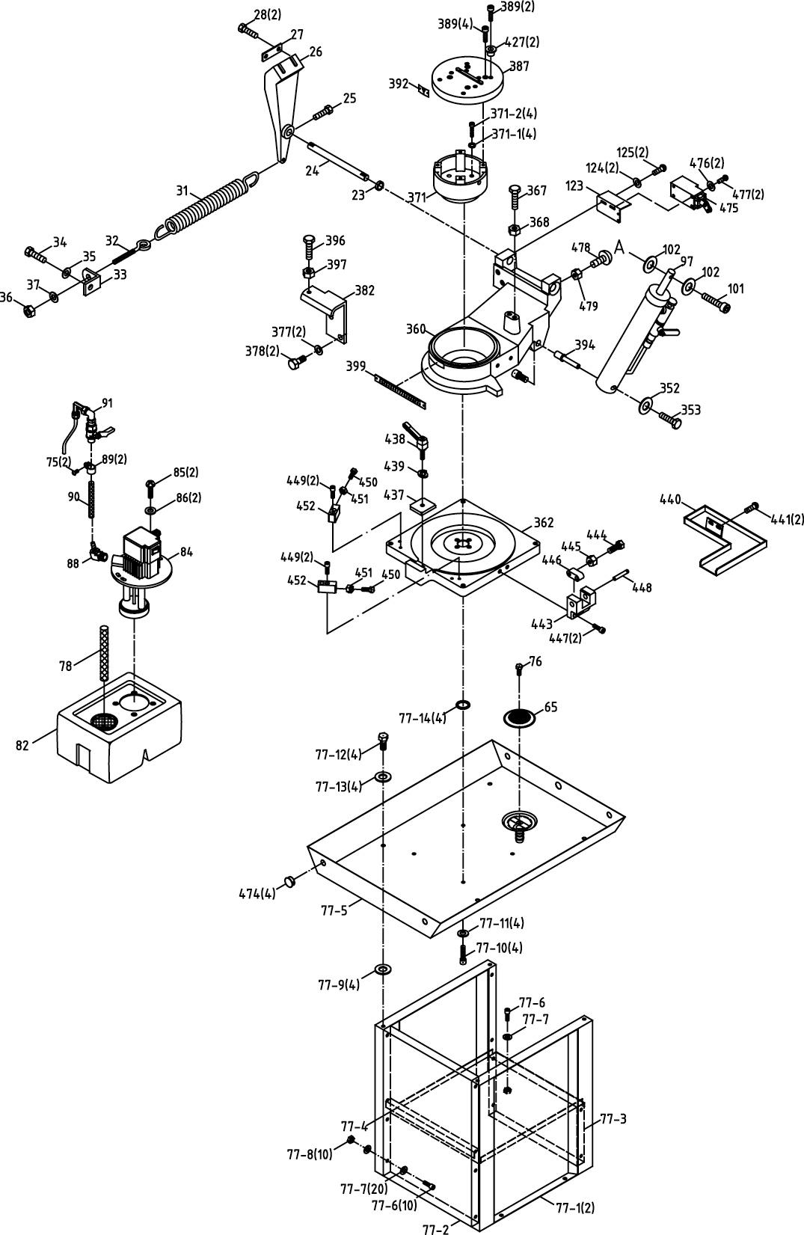

Parts List for the MBS-712
Base Assembly

Index Part
No. No. Description Size Qty.

23 MBS712-023 Bushing 1
24 MBS712-24 Support Rod 1
25 TS-0051051 Hex Cap Screw 5/16" x 1" 1
26 MBS712-026 Pivot Bracket 1
27 MBS712-027 Plate… 1
28 TS-0060061 Hex Cap Screw 3/8" x 1-1/4" 2
31 MBS712-031 Spring 1
32 MBS712-032 Spring Adjusting Screw 1
33 MBS712-033 Spring Bracket 1
34 TS-0081031 Hex Cap Screw 5/16" x 3/4" 1
35 TS-0680031 Flat Washer 5/16" 1
36 TS-0561031 Hex Nut 3/8" 1
37 TS-0680041 Flat Washer 3/8" 1
65 MBS712-065 Filter ……………………………………………… 1
75 MBS712-075 Cross Round Head Screw 3/16" x 3/8" 2
76 TS-0050011 Hex Cap Screw 1/4" x 1/2" 1
77A MBS712-77A Stand Complete Assembly (#77-1 ~ 77-14) 1
77-1 MBS712-77-1 Stand Leg (Right and Left) 2
77-2 MBS712-77-2 Stand Leg (front) 1
77-3 MBS712-77-3 Stand Leg (Back) 1
77-4 MBS712-77-4 Middle Plate of Stand 1
77-5 MBS712-77-5 Chip Pan 1
77-6 TS-1524051 Socket Head Cap Screw M8 x 20 11
77-7 TS-1550061 Flat Washer M8 21
77-8 TS-1540061 Hex Nut M8 10
77-9 MBS712-77-9 Rubber Washer ψ11 4
77-10 TS-1524051 Socket Head Cap Screw M8 x 20 4
77-11 TS-1550061 Flat Washer M8 4
77-12 TS-1491021 Hex Cap Screw M10 x 20 4
77-13 TS-1550071 Flat Washer M10 4
77-14 MBS712-77-14 O-Retainer Ring ψ2 xψ10 4
78 MBS712-078 Hose ………………………………………………1/2" x 200.. 1
MBS712-078N Hose ………………………………………………OD24xID18.5x200.. 1
82 MBS712-082 Coolant Tank 1
84 MBS712-084AE Pump 400V, 3Ph 1
MBS712-084PLE Pump Label for CE (not shown) 1
85 MBS712-085 Cross Round Head Screw 1/4" x 5/8" 2
86 TS-0680021 Flat Washer 1/4" 2
88 MBS712-088 Coupler 3/8"PT x 5/16" 1
89 MBS712-089 Hose Clip 5/8" 2
90 MBS712-090 Hose ………………….…………………………..12xID8x2000 1
91 MBS712-091 Nozzle Cock………………….…………………………… 1
97 MBS712-097 Cylinder Complete Set 1
101 TS-0271141 Socket Set Screw 3/8" x 2-1/2" 1
102 TS-0680041 Flat Washer 3/8" 2
123 MBS712-123 Power Cutting Bracket 1

Index Part
No. No. Description Size Qty.

124 TS-1550031 Flat Washer M5 2
125 MBS712-125 Cross Round Head Screw M5 x 10 2
352 TS-0680031 Flat Washer 5/16" 1
353 TS-0081031 Hex Cap Screw 5/16" x 3/4" 1
360 MBS712-360 Swivel Arm 1
362 MBS712-362 Swivel Base 1
367 MBS712-367 Bolt................…………………………………….1/2" x 2-1/2". 1
368 TS-0561051 Hex Nut 1/2" 1
371A MBS712-371A Fixed Bracket (#371-1 ~ #371-2) 1
371-1 TS-0720091 Spring Washer 3/8" 4
371-2 TS-0271112 Socket Set Screw 3/8" x 1-1/2" 4
377 TS-0680031 Flat Washer 5/16" 2
378 TS-0081031 Hex Cap Screw 5/16" x 3/4" 2
382 MBS712-382 Bracket 1
387 MBS712-387 Cap….. 1
389 TS-1524061 Socket Cap Screw M8 x 25 6
392 MBS712-392 Meter Indicator 1
394 MBS712-394 Cylinder Lower Support 1
396 TS-0051061 Hex Cap Screw 5/16" x 1-1/4" 1
397 TS-0561021 Hex Nut 5/16" 1
399 MBS712-399 Degree-Meter 1
427 MBS712-427 Fix Block 2
437 MBS712-437 Swivel Arm Briquette 1
438 MBS712-438 Knob ……………………………………………… 1
439 TS-0720091 Spring Washer 3/8" 1
440 MBS712-440 Splash Board 1
441 MBS712-441 Cross Round Head Screw 5/16" x 1/2" 2
443 MBS712-443 Protractor Locating Bracket 1
444 TS-0060091 Hex Cap screw 3/8" x 2" 1
445 TS-0561031 Hex Nut 3/8" 1
446 MBS712-446 Protractor Locating Block 1
447 TS-0051011 Hex Cap screw 5/16" x 1/2" 2
448 MBS712-448 Bearing Pin 1
449 TS-0267102 Socket Set Screw 1/4" x 1-1/4" 4
450 TS-0060091 Hex Cap screw 3/8" x 2" 2
451 TS-0561031 Hex Nut 3/8" 2
452 MBS712-452 Swivel Locating Block 2
474 MBS712-474 Snap Bushing 4
475 MBS712-475 Limit Switch 1
476 MBS712-476 Washer M4 2
477 MBS712-477 Pan Head Screw M4 x 25 2
478 MBS712-478 Carriage Screw 5/16” x 3/4” 2
479 TS-0561071 Hex Nut 5/16”…………………..2
**………MBS712-JL………………..Jet Logo (not shown) ………………………...1
**………MBS712-IDE……….……...ID Label for CE (not shown) ………………………...1
**………MBS712-GL….……………Ground Label (not shown) ………………………...1
**………601W-05L003………… ….Warning Label for Eye (not shown) ……………………….. 1
**………601W-05L005…………… .Warning Label for Glasses (not shown) ………………………...1

MBS-712 400/50/3
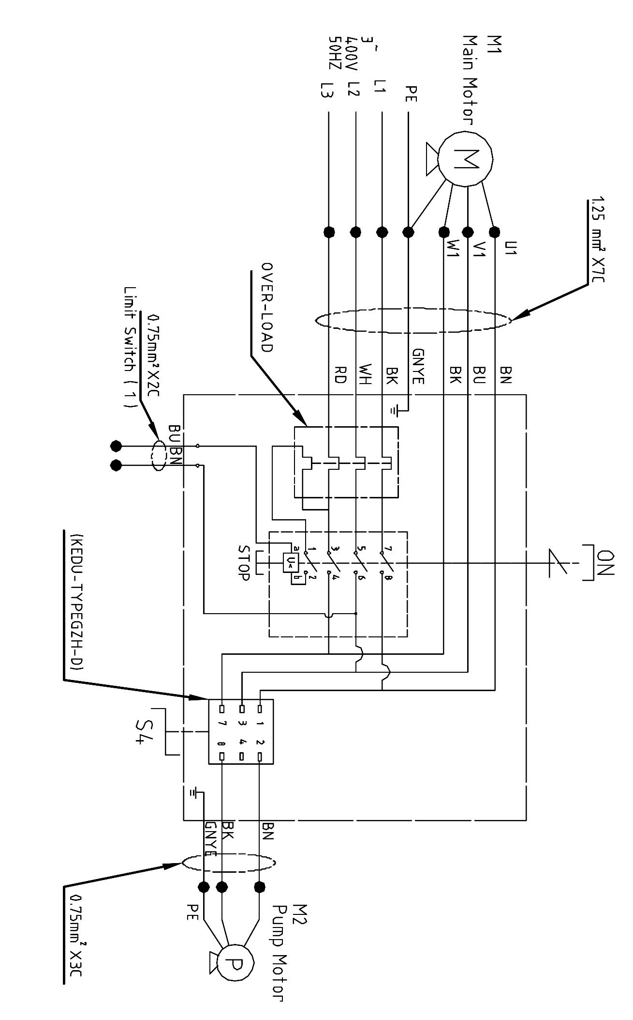
50000430T

 | colour of strands | Litzenfarben | couleur des cordons
BK | black | schwarz | noir
WH | white | weiß | blanc
BU | blue | blau | bleu
RD | red | rot | rouge
BN | brown | braun | brun
GNYE | green-yellow | grün-gelb | vert-jaune
GN | green | grün | vert

 | meaning of symbol | Bedeutung der Zeichen | interprétation
M1 | Main motor | Hauptmotor | Moteur principal
M2 | Pump motor | Kühlmittelmotor | Moteur pompe
S4 | Pump motor switch | Kühlmittel-Schalter | Boution pompe

